Ideation Phase
Empathize & Discover
Date | 14 July 2026
Team ID
Project Name | HouseRent India — MERN Property Rental & Sale Platform
Maximum Marks | 4 Marks

Empathy Map Canvas:
An empathy map is a simple, easy-to-digest visual that captures knowledge about a user's behaviours and attitudes. It helps the team step into the user's shoes before designing HouseRent India, so the platform is built around real renter, buyer, and owner frustrations rather than assumptions.

Persona 1: Priya — Renter / Buyer (Primary User)
27-year-old software professional relocating to Bengaluru for a new job, searching for a 2BHK apartment to rent within a two-week deadline.

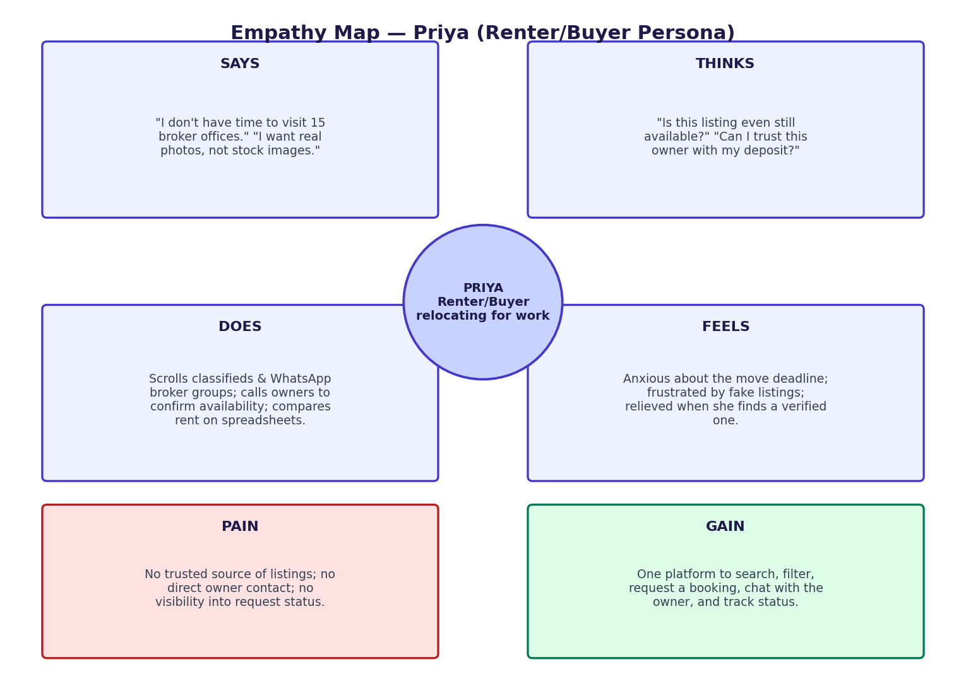
Figure 1: Empathy map canvas for Priya, the primary Renter/Buyer persona

Quadrant | Observation
SAYS | "I don't have time to visit 15 different broker offices." "I want to see real photos, not stock images." "Why do I have to pay brokerage twice?"
THINKS | "Is this listing even still available?" "Can I trust this owner / this platform with my deposit?" "What if the price shown isn't the real price?"
DOES | Scrolls through multiple classifieds sites and broker WhatsApp groups; calls owners directly to confirm availability; compares rent across localities on spreadsheets.
FEELS | Anxious about the moving deadline; frustrated by unresponsive owners and duplicate/fake listings; relieved when she finally finds a verified, well-described listing.
PAIN POINTS | No single trusted source of listings; no way to message an owner directly; no visibility into whether a booking request was even seen; broker fees add up.
GAINS (what would delight her) | One platform to search, filter by budget/city/bedrooms, send a booking request, chat directly with the owner, and track status — all without a broker in between.

Persona 2: Rajesh — Property Owner (Secondary User)
45-year-old owner of three rental units in Pune who currently manages tenant enquiries over phone calls and a paper notebook.
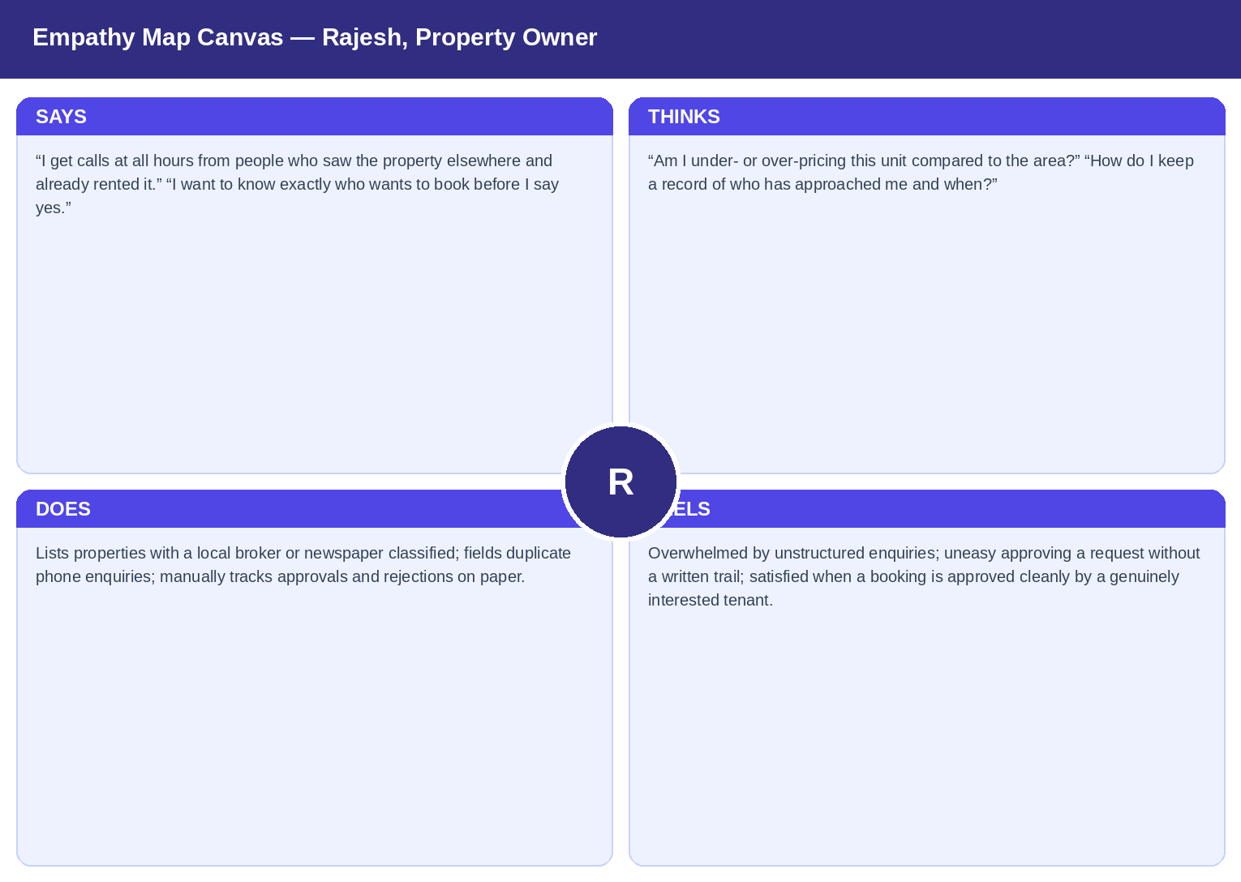
Figure 2: Empathy map canvas for Rajesh, the secondary Property Owner persona
Quadrant | Observation
SAYS | "I get calls at all hours from people who saw the property elsewhere and already rented it." "I want to know exactly who wants to book before I say yes."
THINKS | "Am I under- or over-pricing this unit compared to the area?" "How do I keep a record of who has approached me and when?"
DOES | Lists properties with a local broker or newspaper classified; fields duplicate phone enquiries; manually tracks approvals/rejections on paper.
FEELS | Overwhelmed by unstructured enquiries; uneasy approving a request without a written trail; satisfied when a booking is approved cleanly and the tenant is genuinely interested.
PAIN POINTS | No dashboard of active listings and requests; no easy way to edit rent/details after listing; no direct channel to negotiate with a serious renter.
GAINS (what would delight him) | A single "My Properties" and "Booking Requests" dashboard, one-tap Approve/Reject, in-app chat once a request comes in, and the ability to edit price and details anytime.

